Contents

Course content 6

Section 1: Introduction 6

1. Mule ESB integration 6

2. Integration introduction 8

3. Mule API development life cycle and components 10

Section 2: Mule 4 installation set-up 10

6. Local Environment setup 10

7. Cloud (anypoint platform) registration-> 11

Section 3: Mule basics - develop first mule app, run, debug, export & import mule app 11

9. Web services - rest services basics 12

10. Let's develop first mule app - simple rest service development & run/deploy 13

11. Mule global elements & why connector configurations ? 13

12. Multiple flows in a mule configuration file vs multiple configuration files 13

13. Mule application debugging introduction 13

14. Export a mule application & Import a mule application 13

Section 4: Mule basics - Mule events and mule message structure 13

16. Mule event message structure 14

17. Access mule event payload and attributes – old 15

18. Mule events - extract JSON fields 15

19. Mule events - extract XML elements and XML attributes 15

20. Mule events - extract header parameters and query parameters 15

21. Mule events - extract URI parameters 15

22. Mule variables - create and extract variables 15

23. Mule variables - need of variables in mule flow 15

24. Rest services - setup http hard coded response in listener connector 15

25. Rest services - setup http dynamic response in listener connector 15

**Section 5: Mule basics - Basic transformations** 26. Transformations introduction 15

27. Transform JSON input to XML output 15

28. Transform XML input to JSON output 15

29. Transform Message connector preview feature 15

30. Basic transformations - old 15

**Section 6: Mule rest-full services (database) as provider - simple use case to get started** 31. Install oracle and sql developer 15

32. Mule rest service to post JSON payload to insert to database 15

33. Mule rest service to post XML payload to update to database 15

34. Mule rest service to fetch records from database using query parameter 15

35. Mule rest service by URI param to delete record in table using stored proc call 15

**Section 7: DataWeave language – basics** 36. DataWeave language introduction 15

37. DataWeave selectors part 1 15

38. DataWeave selectors part 2 15

39. DataWeave datatypes 15

40. DataWeave variables - pre defined variables 15

41. DataWeave variables - Create flow level variables in transform message 15

42. DataWeave variables - Create variables in DataWeave headers 15

43. DataWeave - type coercion 15

44. DataWeave - date type coercion 15

45. DataWeave - introduction to now() function 15

**Section 8: Mule database module - first system api uhub (database) sapi implementation** 46. Real time use case uhub-sapi requirement walkthrough & db scripts execution 15

47. Real time use case uhub-sapi rest provider development 15

48. Mule database auto-generated keys feature 15

49. Calling database stored procedure with in and out parameters 15

50. Real time use case - practice activity 15

51. Transaction ID, Correlation ID over integrations & Choice router introduction 15

52. Database - Writing dynamic database queries 16

53. Database - connection pooling 16

**Section 9: Mule validation module and flow types** 54. Mule validations introduction 16

55. Develop required validations in real time use case 16

56. Types of mule flows 16

57. Payload and varaibles propagation among main flows and sub flows 16

58. JSON schema validation 16

59. XML schema validation 16

**Section 10: Mule error handling** 60. Error handling introduction & mule default error handling 16

61. Error handling using on-error-propagate vs on-error-continue 16

62. Multiple errors handling in flow 16

63. Multiple error types selection & common error handling in a error handling block 16

64. Error handling - error mapping feature on connectors 16

65. Error handling - Raise Error - Raising custom errors and handling custom errors 16

66. Error handling on group of event processors using try block & scenarios 16

67. Error handling b/w main flows & sub flows and scenarios 16

68. Error handler - conflicts b/w global error handler vs local error handler 16

69. Error handler - solution to solve conflict b/w global & local error handlers 16

**Section 11: Anypoint platform introduction & access management** 70. Anypoint platform capabilities 16

71. Configure business groups, environments in an organization 16

72. Configure users , roles and permissions within an organization 16

**Section 12: Anypoint Platform - Design Center - Design API's Using RAML** 73. Design API specification using RAML introduction 16

74. Design API specification using RAML for a simple use case to get started 16

75. Mocking API specification & scenarios 16

76. Resource's as same name with multiple http methods & nested JSON, XML payload's 16

77. API spec with headers, URI parameters, query parameters & deal array of objects 16

**Section 13: Anypoint Platform - Design Center - Design Fragments Based API's Using RAML** 78. RAML fragments introduction 16

79. Fragments - data types 16

80. Fragments - Library 16

81. Fragments - example 16

82. Fragments - traits 16

83. Fragments - security scheme - basic auth 16

84. Fragments - security scheme - oauth 2.0 16

85. Introducing health check api 16

**Section 14: Anypoint Platform - Anypoint Exchange - Publishing API's to Exchange** 86. Anypoint exchange introduction 16

87. Publish API specification to exchange 16

88. API Exchange portal - API documentation 17

89. Simulate, feedback and validation of API 17

90. Add contributors to exchange API assets 17

91. Share API exchange portal access to external clients 17

**Section 15: API based project development and real time scenarios** 92. Create API based project 17

93. API kit router 17

94. API validations using RAML 17

95. Mule application real time naming standards 17

96. Mule application real time project structure 17

97. API based project implementation 17

98. Real time global error handler 17

99. Deploy API to mule runtime cloud hub 1.0 17

100. Setup a free cloud database 17

101. Point mule application to cloud database 17

Section 16: Mule configure properties per environment 102. Mule configuration properties file to read properties 17

103. Mule configuration YAML file to read properties 17

104. Mule secure configuration properties to read properties 17

105. Load property files dynamically by environment 17

**Section 17: Anypoint platform - Runtime Manager - Deployment to CloudHub 1.0** 106. Configure CloudHub runtime properties & deploy application to CloudHub 17

107. Runtime monitoring, dashboard, vCores, workers - vertical & horizontal scaling 17

108. Safely hide application runtime manager properties 17

109. Runtime manager - Monitoring insights of runtime application 17

110. Runtime - Changing log levels to debug & enable verbose logs on mule components 17

111. Runtime manager - Setup alerts on applications & servers critical conditions 17

**Section 18: Anypoint platform - API Manager - API Management** 112. API Management & API gateway introduction 17

113. Create API in API Manager and about API instance id 17

114. API auto discovery 17

115. Policies - basic authentication 17

116. Policies - client id enforcement policy 17

117. Policies - rate limiting policy 17

118. Policies - Rate limiting - SLA based policy 17

119. Policies - JSON and XML threat protection policies 17

120. Policies - IP allow list and IP block list policies 17

121. Policies - Setup automatic policies across API's and CORS policy 17

122. Policies - Header injection and header removal policies 17

123. Policies - Message logging policy 17

124. Policies - Setup oauth provider and apply oauth 2.0 policy 17

125. API Proxy-Create proxy application on external services, decode & API Management 18

126. Promote API to higher environment 18

Section 19: Anypoint platform - Runtime Manager - Deployment to CloudHub 2.0 18

Section 20: Anypoint Platform - Design Center - Design API's Using OAS 18

Section 21: Mule JMS 18

Section 22: On premise deployment and hybrid deployment 18

Section 23: Mule HTTP Request - Consume REST services 18

Section 24: Mule SOAP services (web services) 18

Section 25: Mule File and FTP 18

Section 26: Mule Salesforce integration 18

Section 27: Mule scatter-gather router 18

Section 28: Mule scopes 18

Section 29: Dataweave 2.0 18

Section 30: Munit 18

Section 31: Mule with DevOps 18

Section 32: API LED Connectivity 18

Section 33: Bonus - Mule real time project (Health domain) 18

# Course content

## Section 1: Introduction

1. Mule ESB integration  
Mule ESB is a lightweight java-based enterprise service bus (ESB) and integration platforms that allows developers to connect applications together quickly and easily, enabling them to exchange data.

Benefits:

Reduced development time

Cloud enablement

Designing API’s

API Management

Mule community vs enterprise edition

Mule API SDLC

Web-application->anypoint platform

* Design center-To design the api’s
* Exchange – To maintain the API artifact as a repository
* Management Center –
  + Access Management – To do identity management and configurations of users, runtimes, environments
  + API Manager – To
  + Runtime Manager – To deploy
  + API Governance –
  + Visualizer –
  + Monitoring –
  + Secrets Manager –

Ide->anypoint studio

### 2. Integration introduction

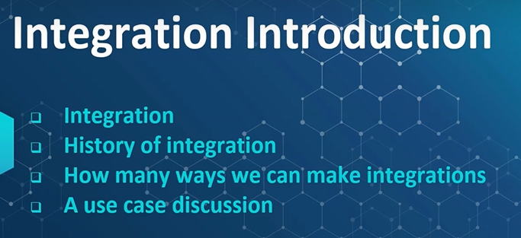

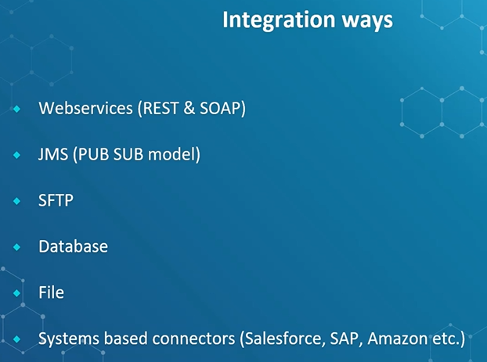

Webservices>JMS> System Based Connectors(salesforce,SAP,Amazon)

Usecase

Types of Integration

A Diagoniost Chain->Diagnosed Data-> Has lots of Patients data

A Hospital chain wants to use this

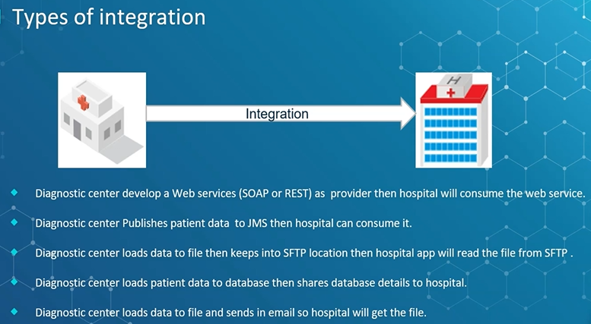

### 3. Mule API development life cycle and components

## Section 2: Mule 4 installation set-up

### 6. Local Environment setup

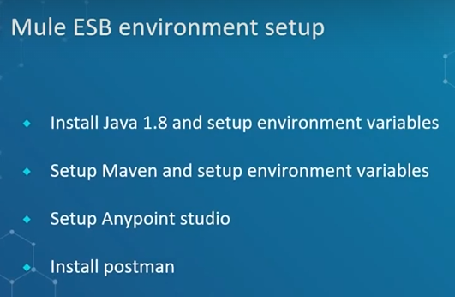

Java installation

url -> Java 1.8 -> jdk-8u281-windows-x64.exe

Maven Binary Zip -> apace-maven-3.6.3-bin.zip

Env_Variables

JAVA_HOME-> path

Path->java_path/bin

MAVEN_HOME-> path

Path->java_path/bin

For javaw.exe setup

Configure it to point to your JDK installation as the default VM

Java\jdk..\bin\javaw.exe

In .ini file -> replace -vmargs to -vm c:\java\jdk..\bin\javaw/exe

### 

### 7. Cloud (anypoint platform) registration->

REGISTER ONLINE

## Section 3: Mule basics - develop first mule app, run, debug, export & import mule app

8. Overview of Anypoint Studio  
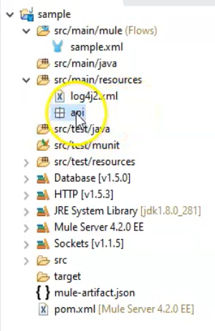  
src/main/mule ->sample.xml-> mule configuration file  
src/main/resources -> files  
src/main/munit -> munit files  
src/main/resources -> munit files

src/main/ -> .classpath files generated  
src/test/ -> .classpath files generated  
target->deployable jar file generated  
mule-artifact.json -> mule version  
pom.xml-> All mule projects are maven projects  
log4j.xml -> logger component  
connectors added from pom  
mule server-> server running

9. Web services - rest services basics  
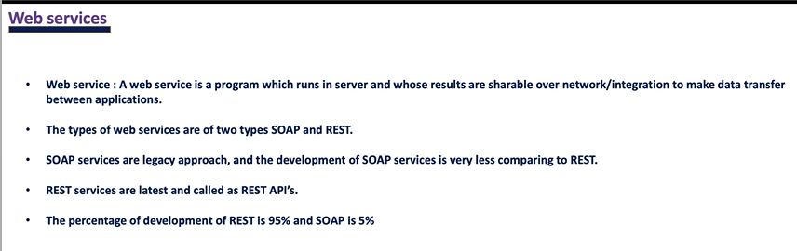  
  
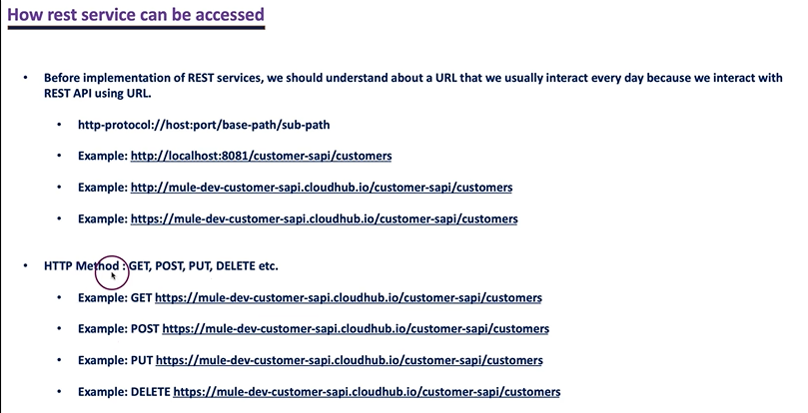  
  
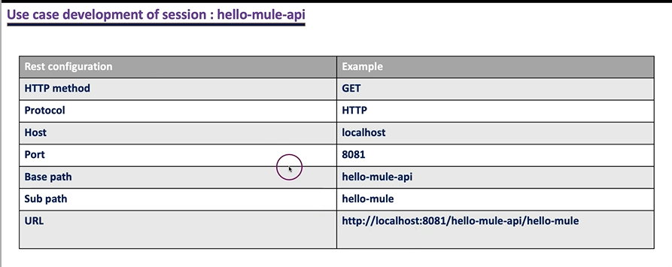

### 10. Let's develop first mule app - simple rest service development & run/deploy

|  |  |
| --- | --- |
|  | Make a mule app using above methods <http://localhost:8081/hello-mule-api/hello-mule> |

11. Mule global elements & why connector configurations ?  
Global elements are used in different services also.-> base-path same but different sub-path  
We should not use same ports for multiple configurations when configurations are running in one application/server

12. Multiple flows in a mule configuration file vs multiple configuration files  
Ans: create multiple mule configuration files

13. Mule application debugging introduction  
x+y,breakpoint,resume next

### 14. Export a mule application & Import a mule application

Import and export mule projects

Section 4: Mule basics - Mule events and mule message structure  
  
15. Mule event sources, event processors & event message  
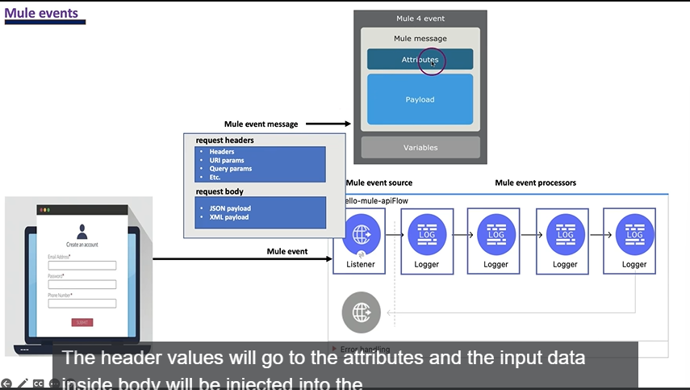  
  
Mule event sources(listners)-> Mule event sources are the trigger points which allows client requests to process this business logic.  
Mule event processors(components)-> The mule event processors are responsible to do the business that we developed.

16. Mule event message structure

### 17. Access mule event payload and attributes – old attributes.queryParams attributes.uriParams payload.age

### 18. Mule events - extract JSON fields

### 19. Mule events - extract XML elements and XML attributes

### 20. Mule events - extract header parameters and query parameters

### 21. Mule events - extract URI parameters

### 22. Mule variables - create and extract variables

### 23. Mule variables - need of variables in mule flow

### 24. Rest services - setup http hard coded response in listener connector body: “success”, status code :200 , reason phase : “ok”

### 25. Rest services - setup http dynamic response in listener connector

### Section 5: Mule basics - Basic transformations 26.

### 28. Transform XML input to JSON output

### 30. Basic transformations - old A screen shot of a computer Description automatically generated for json payload root element is optional but in xml it is mandatory xml: for making root element -> emp: {} title : payload.book.title.@lang | <title lang=”en”>Everyday Italian</title> (output is json) title @(lang: payload.item.properties.language) : payload.item.properties.title(to assign attributes when json to xml) for schema generation: xml:

Freeformatter.com/xsd-generator-> xml schema generation  
 employee_schema.xsd

### Section 6: Mule rest-full services (database) as provider - simple use case to get started 31. Install oracle and sql developer

Sql workbench->shell,server,bench->give bin path of server in env variables.

### 32. Mule rest service to post JSON payload to insert to database

**Pm curl**

curl --location 'http://localhost:8091/emp-sapi/create-employee' \

--header 'Content-Type: application/json' \

--data '{

"employeeID": 123,

"employeeName": "Chinna",

"employeeStatus": "A"

}'

insert into emp(emp_id, emp_name, emp_status) values(:empID, :empName, :empStatus)

{

empID: payload.employeeID,

empName: payload.employeeName,

empStatus: payload.employeeStatus

}

33. Mule rest service to post XML payload to update to database  
<?xml version="1.0" encoding="UTF-8"?>

<employee>

    <employeeID>123</employeeID>

    <employeeStatus>inActive</employeeStatus>

</employee>

update emp set emp_status=:empStatus where emp_id=:empID

{

empStatus: payload.employee.employeeStatus,

empID: payload.employee.employeeID

}

34. Mule rest service to fetch records from database using query parameter

### 35. Mule rest service by URI param to delete record in table using stored proc call stored procedure DELIMITER //

### CREATE PROCEDURE delete_emp(IN id INT, IN name VARCHAR(255))

### BEGIN

### DELETE FROM emp

### WHERE emp_id = id AND emp_name = name;

### END;

### //

### DELIMITER ;

### Section 7: DataWeave language – basics 36. DataWeave language introduction

### 37. DataWeave selectors part 1

### 38. DataWeave selectors part 2

### 39. DataWeave datatypes

### 40. DataWeave variables - pre defined variables

### 41. DataWeave variables - Create flow level variables in transform message

### 42. DataWeave variables - Create variables in DataWeave headers

### 43. DataWeave - type coercion

### 44. DataWeave - date type coercion as Date {format: “dd-MM-yyyy”}

### 45. DataWeave - introduction to now() function

### Section 8: Mule database module - first system api uhub (database) sapi implementation 46. Real time use case uhub-sapi requirement walkthrough & db scripts execution

### 47. Real time use case uhub-sapi rest provider development

### 48. Mule database auto-generated keys feature

### 49. Calling database stored procedure with in and out parameters

### 50. Real time use case - practice activity

### 51. Transaction ID, Correlation ID over integrations & Choice router introduction

### 52. Database - Writing dynamic database queries

### 53. Database - connection pooling

### Section 9: Mule validation module and flow types 54. Mule validations introduction

### 55. Develop required validations in real time use case

### 56. Types of mule flows

### 57. Payload and varaibles propagation among main flows and sub flows

### 58. JSON schema validation

### 59. XML schema validation

### Section 10: Mule error handling 60. Error handling introduction & mule default error handling

### 61. Error handling using on-error-propagate vs on-error-continue

### 62. Multiple errors handling in flow

### 63. Multiple error types selection & common error handling in a error handling block

### 64. Error handling - error mapping feature on connectors

### 65. Error handling - Raise Error - Raising custom errors and handling custom errors

### 66. Error handling on group of event processors using try block & scenarios

### 67. Error handling b/w main flows & sub flows and scenarios

### 68. Error handler - conflicts b/w global error handler vs local error handler

### 69. Error handler - solution to solve conflict b/w global & local error handlers

### Section 11: Anypoint platform introduction & access management 70. Anypoint platform capabilities

### 71. Configure business groups, environments in an organization

### 72. Configure users , roles and permissions within an organization

### Section 12: Anypoint Platform - Design Center - Design API's Using RAML 73. Design API specification using RAML introduction

### 74. Design API specification using RAML for a simple use case to get started

### 75. Mocking API specification & scenarios

### 76. Resource's as same name with multiple http methods & nested JSON, XML payload's

### 77. API spec with headers, URI parameters, query parameters & deal array of objects

### Section 13: Anypoint Platform - Design Center - Design Fragments Based API's Using RAML 78. RAML fragments introduction

### 79. Fragments - data types

### 80. Fragments - Library

### 81. Fragments - example

### 82. Fragments - traits

### 83. Fragments - security scheme - basic auth

### 84. Fragments - security scheme - oauth 2.0

### 85. Introducing health check api

### Section 14: Anypoint Platform - Anypoint Exchange - Publishing API's to Exchange 86. Anypoint exchange introduction

### 87. Publish API specification to exchange

### 88. API Exchange portal - API documentation

### 89. Simulate, feedback and validation of API

### 90. Add contributors to exchange API assets

### 91. Share API exchange portal access to external clients

### Section 15: API based project development and real time scenarios 92. Create API based project

### 93. API kit router

### 94. API validations using RAML

### 95. Mule application real time naming standards

### 96. Mule application real time project structure

### 97. API based project implementation

### 98. Real time global error handler

### 99. Deploy API to mule runtime cloud hub 1.0

### 100. Setup a free cloud database

### 101. Point mule application to cloud database

### Section 16: Mule configure properties per environment 102. Mule configuration properties file to read properties

### 103. Mule configuration YAML file to read properties

### 104. Mule secure configuration properties to read properties

### 105. Load property files dynamically by environment

### Section 17: Anypoint platform - Runtime Manager - Deployment to CloudHub 1.0 106. Configure CloudHub runtime properties & deploy application to CloudHub

### 107. Runtime monitoring, dashboard, vCores, workers - vertical & horizontal scaling

### 108. Safely hide application runtime manager properties

### 109. Runtime manager - Monitoring insights of runtime application

### 110. Runtime - Changing log levels to debug & enable verbose logs on mule components

### 111. Runtime manager - Setup alerts on applications & servers critical conditions

### Section 18: Anypoint platform - API Manager - API Management 112. API Management & API gateway introduction

### 113. Create API in API Manager and about API instance id

### 114. API auto discovery

### 115. Policies - basic authentication

### 116. Policies - client id enforcement policy

### 117. Policies - rate limiting policy

### 118. Policies - Rate limiting - SLA based policy

### 119. Policies - JSON and XML threat protection policies

### 120. Policies - IP allow list and IP block list policies

### 121. Policies - Setup automatic policies across API's and CORS policy

### 122. Policies - Header injection and header removal policies

### 123. Policies - Message logging policy

### 124. Policies - Setup oauth provider and apply oauth 2.0 policy

### 125. API Proxy-Create proxy application on external services, decode & API Management

### 126. Promote API to higher environment

## Section 19: Anypoint platform - Runtime Manager - Deployment to CloudHub 2.0

## Section 20: Anypoint Platform - Design Center - Design API's Using OAS

## Section 21: Mule JMS

## Section 22: On premise deployment and hybrid deployment

## Section 23: Mule HTTP Request - Consume REST services

## Section 24: Mule SOAP services (web services)

## Section 25: Mule File and FTP

## Section 26: Mule Salesforce integration

## Section 27: Mule scatter-gather router

## Section 28: Mule scopes

## Section 29: Dataweave 2.0

## Section 30: Munit

## Section 31: Mule with DevOps

## Section 32: API LED Connectivity

## Section 33: Bonus - Mule real time project (Health domain)